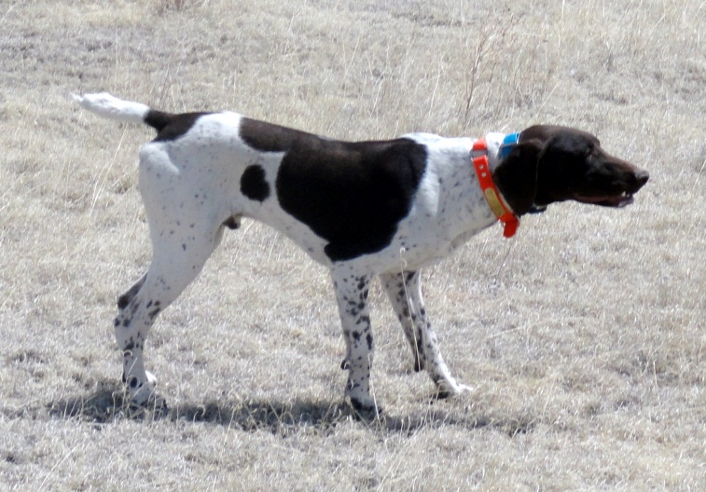
HIGH POINT’S ROYAL ROYCE
DOB: 04/08/10
SEX: MALE
AKC #: SR1938701
BREEDER: PAYTON BRISCOE
OWNER: SUSAN HERREL
LIVER AND WHITE, PATCHED

PARENTS______GRANDPARENTS _3RD GENERATION__ ___4TH GENERATION____ __ 5TH GENERATION
Slick’s Country Clown NFC Heide’s Mighty City Slicker
NSTRA CH Black Forest Brodie SN815107/04 Oakridge Birdie
SN918185/08
NSTRA CH Black Forest Sage Sir Moe Bo
NSTRA CH Black Forest Shooter SN759617/08 Ford Hill Sadie
SR194626/01
Arthur V Feinschmecker DC Ziel V Feinschmecker
Moses’ Maggie Mae SN318358/03 Chicoree’s Almond Joy
SN805536/05
Moses’ Blue Streak Bluey
SN161397/05 Cochrane Whitney Keefer
Black Forest Wyatt
SR399914/05 NFC Heide’s Mighty City NFC FC Sanjo Sin City Slicker
Slick’s Country Clown Slicker SM845855/03 FC Heide Ho-Pinehurst
SN815107/04
Oakridge Birdie NFC FC Rawhides Clown
NSTRA CH Black Forest Jewel SN331414/06 Oakridge Josie
SN918185/07
Sir Moe Bo Prince’s I Saul The Light
NSTRA CH Black Forest Sage SN294204 Prince’s Amazing Grace
SN759617/08
Ford Hill Sadie Schmidt’s Ace
SN389060/02 Ford Hill Classy Sassy

FC AFC Downs Chocolate NAFC FC AFC Edlou’s Suoersonic
FC AFC Gabbe’s High Plains Moose SE358021 Whitesmoke’s Calamity Grace
Hurricane SF900309
NAFC FC AFC Ranger’s FC Ammertals Boss Ranger
FC Tjust Dandy Man Essergreif Gabbe SD426100 FC Essergreif’s Esse
SN918528/04
FC Rosehills Bilbo Baggins FC Craigs Moontige
FC AFC Wildfire’s Brown L SF131330 FC Brown LS Ruby
Dot Com SN349701/07
FC AFC Pete’s Pyrotechnic FC AFC Nicky Von Blitz
Peggy SF942253 NAFC FC AFC Wildfire’s Angel
Briscoe’s Maggie
SR468570/04 NFC FC Sanjo Sin City Slicker Blue Bayou
NFC Heide’s Mighty City SE037262 Kiss Me Kate
Slicker SM845855/03
FC Heide Ho-Pinehurst Julson Jesse
Cajun’s Sweet Liberty SE775659 Erbe’s White Streaker
SN045034/05
FC Rosehills Bilbo Baggins FC Craigs Moontige
Cajun’s Burning Desire JH SF131330 FC Brown LS Ruby
SN384535/01
FC Rawhides Daisey FC Jiggs White Smoke
SF886679 Sport’n Judys Nodamuall

