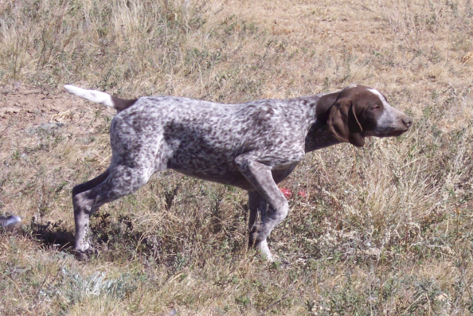
HIGH POINT’S SHIMMERING SILOHOUETTE
Sex: Female
AKC Registration #: SR43757810
Whelped: 6/15/2007
Breeder: Susan Herrel
Owner: Susan Herrel
Color/Markings: Liver & White, Patched & Ticked

Parents Grandparents 3rd Generation 4th Generation 5th Generation
Bud Bataa Calvin FC Kao’s Dirty Dude
Pheasant Buster SF997181 Kao’s Corky Lyons
SN237480
White River Ashcroft Lucy CH Serakraut’s Scotch Neat
Tanner Buscal Royale SN152912/05 CH Shadywood’s Show Off
SN720930
Gandalf the Grey II Cibolo Creek Benito
Miss High Caliber SM849426/09 FC Brown LS Ruby
SN478146 FC AFC
Fraulein Hausenpheffer Gabbe’s High Plains Hurricane
SN197188/08 Miss Greta Buck
Rawhide Clown’s Chocolate Chip NAFC FC AFC
SR277028/07 FC AFC Down’s Chocolate Edlou’s Supersonic
FC AFC Gabbe’s High Moose SE58021 Whitesmoke’s Calamity Grace
Plains Hurricane SF900309
NAFC FC AFC Ranger’s FC Ammertal’s Boss Ranger
Maggie Wildfire Essergreif’s Gabbe SD426100 FC Essergreif’s Esse
SN874713
NFC FC Rawhides Clown FC Jiggs White Smoke
Smokey J R Rose SF290858 FC Rawhides Jossie Wells
SN391208/04

NFC Heide’s Mighty City FC Sanjo Sin City Slicker
Slick’s Country Clown SM845503 FC Heide Ho-Pinehurst
SN81510704
Oakridge Birdie NFC FC Rawhides Clown
NSTRA CH Black Forest Brodie SN331414/06 Oakridge Josie
SN91818508
Sir Moe Bo Prince’s I Saul The Light
NSTRA CH Black Forest SN294204/03 Prince’s Amazing Grace
Sage SN75961708
Ford Hill Sadie Schmidt’s Ace
SN389060/02 Ford Hill Classy Sassy
NSTRA CH High Plain’s You Dazzle Me
SR19462604 DC Ziel V Feinschmecker FC AFC Beier’s Evolution
Arthur V Feinschemecker SF713219 FC Brookvue’s Gerda Garbo
SN1835803 FC AFC
Chicoree’s Almond Joy Chicoree’s Cherokee Jake
Moses’ Maggie Mae SF319844 FC Essers Wendy VD Wildburg
SN80553605
Bluey FC Sundance Cisco Kid
NSTRA CH Mose’s Blue SF057135 FC AFC Dee’s Call Girl
Streak SN161397/05
Cochrane Whitney Keefer Der Fallschirmjager MH
SM879177 In Due Time Dusty

