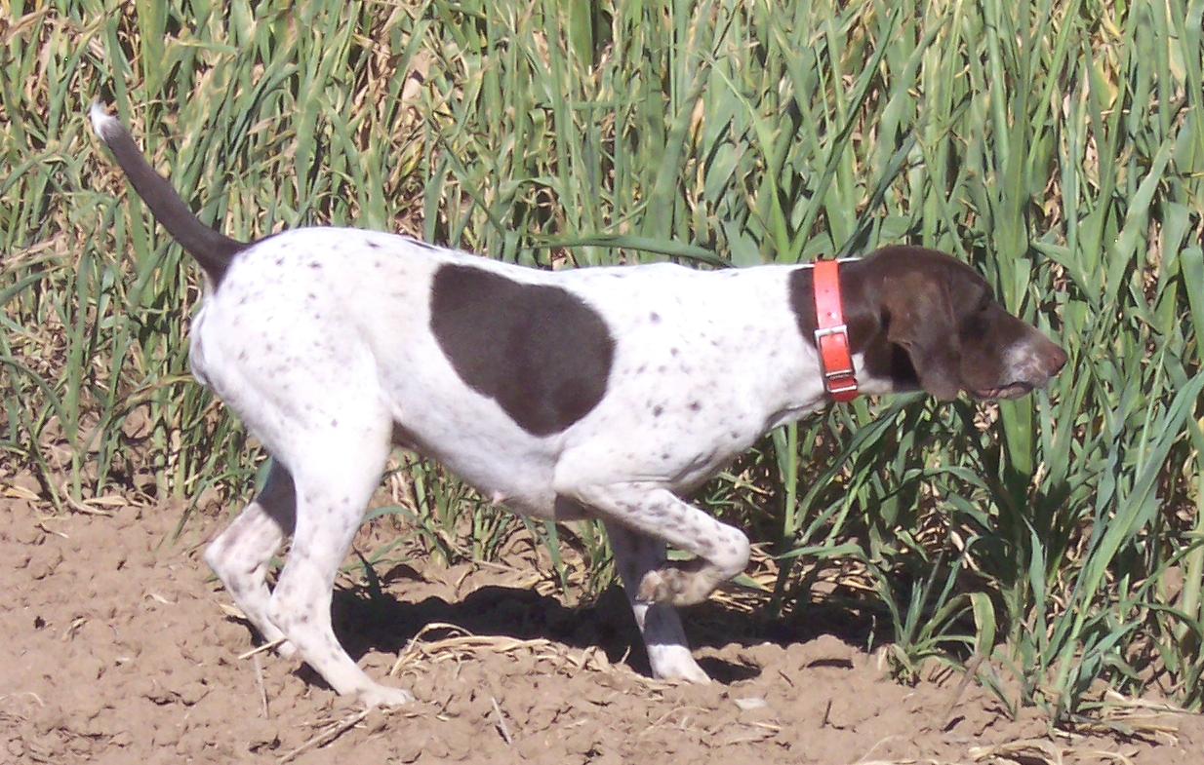
Thunder Mountains Star

Sex: Female
AKC Reg. No. SR10733802
Whelped: 07/01/2003
Breeder: Michael A Porter Owner: Susan rrel Color/Markings: White & Liver, Patched & Ticked
Owner: Susan Herrel
Color: White & Liver, Patched & Ticked

Parents Grandparents 3rd Generation 4th Generation 5th Generation

NFC Rip Traf Von Bess FC V Thalberg’s Fritz II
DC The Flying Dutchman Mitzi Grabenbruch Beckum
V Rip Traf SB799763
FC Degidio’s Will-O-The NFC Thalberg’s Seagraves Chayne
FC Sporty V Rip Traf Wisp Wendy Ammertals Kitt Von Shinback
SF233008
DC Apocalypse Von Greif NFC DC Erlicher Abe
Cindy V Greif Ginger Von Hessenwald Greif
SE507368
NSTRA CH Teton’s Sport Melmar’s Colette Jaablitz Sohl Von Shilo
SN48824304 Melmar’s Albrecht Boomer

Beier’s Ace Thelma V Adlerfels
FC AFC Beier’s SD698829 Neika Meister V Shilo
Evolution SD933543
Neika Meister Jagerin DC Erlicher Abe
An Illusion By Design SD698830 Neika Meister V Shilo
SM79602301
FC Teton’s Ace V Shilo FC AFC Shilo V Hessenwald
FC Aces Prima Banane FC AFC Angel’s Queen of Points
SE045942

NSTRA CH Lord Rudolph V Storkhund
NSTRA CH Grace’s Maximillion V Whiteside Punch Ann
F M Rommel SC892884
NSTRA CH Hampton’s Rex V Bess
NSTRA CH Herr Magnum Shotzie Rip’s Hoppie V Bess
Opus SE300583
DC Goldenwest Chucko Goldenwest Blick’s Fritz
NSTRA CH Goldenbrooke’s Waldenbergs Chayne’s Beasley
Pasha V Lee SD095480
FC Blick’s Meadowbrooke NFC Blick Shinback
NSTRA CH Map’s Suzy Q FC Erdenreich’s Maize
SN166261/07
Pheasant Run Shooter DC Y Bold Rothenuffein
Mosegaard’s Dude Bridget V Hainholz, BRB
SE028435
Mosegaard’s Bo V FC Ripper J V Bess
Bodenberg FC Mosegaard’s Willemina
NSTRA CH Map’s
Jagermeister Babe SF912682 CH Wil-Lyn King of DC Erick V Enzstrand Hearts CH Clsambra’s Gold Mein
Jagermeister-Samantha
SF 101379 Sully’s Delilah Barney Miller Radbach
CH Chelsea Ivanfeld

