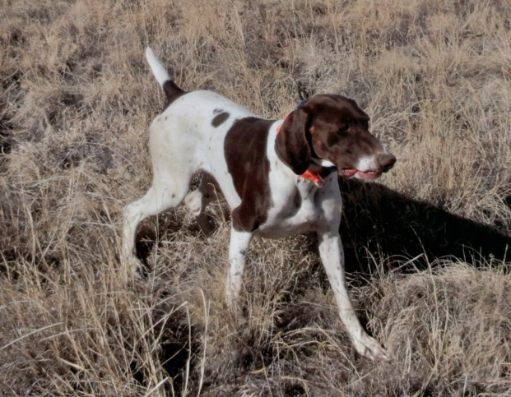
HIGH POINT’S DRAMBUIE’S MYSTIQUE
SEX: FEMALE
AKC REGISTRATION #: SR6193605
DATE WHELPED: 03/21/2010
OWNER: SUSAN HERREL
BREEDER: SUSAN HERREL
COLOR: WHITE AND LIVER, PATCHED AND TICKED

PARENTS GRANDPARANTS 3RD GENERATION 4TH GENERATION 5TH GENERATION
Phesant Buster Bud Bataa Calvin
Tanner Buscal Royale SN237480 White River Ashcroft Lucy
SN720930
Miss High Caliber Gandalf The Grey II
Rawhide Clowns Chocolate Chip SN478146 Fraulein Hausenpheffer
SR27702807 FC AFC FC AFC
Gabbe’s High Plains Hurricane Downs Chocolate Moose
Maggie Wildfire SF900309 NAFC FC AFE Ranger’s Essergreif’s Gabbe
SN874713
Smokey J R Rose NFC FC Rawhides Clown
SN319208/04
High Point’s Rawhide Clown Rico’chet
SR43757809 Slick’s Country Clown NFC Heide’s Mighty City
NSTRA CH Black Forest Brodie SN81510704 Oakridge Birdie
SN91818508
NSTRA CH Black Forest Sage Sir Moe Bo
NSTRA CH High Plains You Dazzle Me SN75961708 Ford Hill Sadie
SR19462604
Arthur V Feinschmecker DC Ziel V Feinschmeker
Moses Maggie Mae SN1835803 Chiroree’s Almond Joy
SN80553605
NSTRA CH Moses’ Blue Streak Bluey
SN161397/05 Cochrane Whitney Keefer

Pheasant Buster Bud Bataa Calvin
Jack B. Nimble SN237480/03 White River Ashcroft Lucy
SN671537/03
Miss High Caliber Gandalf The Grey II
CH Woodrow Kingston SN478146/02 Fraulein Hausenpheffer
SN80865010
Sir Moe Bo Prince’s I Saul The Light
Jada B Quick SN294204/03 Prince’s Amazing Grace
SN574047/09
Laybourn’s Meg Buck Shot Cheyne
SN423957/02 Mosegaards Dandy Sasha
RNG’s High Plains Merlot
SR07028905 Ward Von Burger JH Ward Von Hunter
Gauge VIII SN26018305 Mayes Jill Babe
SN48475904
Zoe Blazing Star Bradshaw’s Dixie Blazer
SN29413607 Bradshaw’s Autumn’s Star
RNG’s High Plains Anthem
SN81595309 Milky Way Kuhlman Sly’s Roscoe Von Bowregard
Ingrid Bergman Akeska SN39230103 Kettlewell’s Sadie
SN59910803
Sadie Renee Kuhlman Sir Maxamillion IV
SN30547804 Fraulein Josifein

