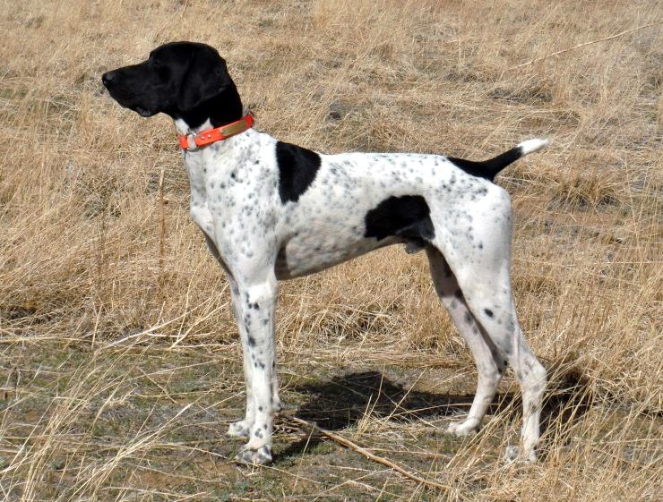
HIGH POINT’S REGAL REVEILLE
SEX: MALE
DOB: 2/11/2013
AKC NUMBER: SR7635505
COLOR: BLACK AND WHITE, PATCHED AND TICKED
BREEDER: LILLIAN TANGEMAN
OWNER: SUSAN HERREL

PARENTS GRANDPARENTS 3RD GENERATION 4TH GENERATION 5TH GENERATION
NFC Heide’s Mighty City NFC FC Sanjo Sin City Slicker
Slick’s Country Clown Slicker SM854855/03 FC Heide Ho-Pinehurst
SN815107/04
NSTRA CH Black Forest Bordie Oakridge Birdie NFC FC Rawhides Clown
SN918185/08 SN331414/06 Oakridge Josie

Sir Moe Bo Prince’s I Saul the Light
NSTRA CH Black Forest Sage SN294204/03 Prince’s Amazing Grace
SN759617/08
NSTRA CH Black Forest Five Oclock Miller Tyme Ford Hill Sadie Schmidt’s Ace
SR475728/05 SN389060/02 Ford Hill Classy Sassy

FC AFC Rusty’s Blue Earth FC Dixieland’s Rusty
Rugerheim’s Quest Herr Ruger Rexx SG018272 My Angel Mia
SN688163/02
Rawhide’s You Figure It FC Rawhide’s Lexington Jake
NSTRA CH Black Forest Clown’s Rio Out SM835743/05 Hadlock’s Captain’s Lady
SR203555/02
NFC FC Rawhide’s Clown FC Jiggs White Smoke
Ms. Betsy’s Darling Clown SF290858 FC Rawhide’s Jossie Wells
SR138352/01
Docs Darling Dutches NFC DC Desert Dutch
SN140677/02 Justin’s White Tessa

NFC FC Rawhide’s Clown FC Jiggs White Smoke
FC Showtime’s Rollin’ Thunder SF290858 FC Rawhide’s Jossie Wells
SN444780/02
Grouse Tales Wild Card Lehmschlogs Alles FC Lehmschlogs Eager Deiter
SR106699/01 Schlaft SM83165203 FC NFC Lehmschlogs Wildfire Dandi

Whiskey Runs Dolamite NSTRA CH Whiskey Runs Bo
Fancy’s Wild Card SE666950 NSTRA CH Whiskey Runs Dot
SN366182/05
Shadowrock’s Widowmaker NSTRA CH Fancy White Trash WW’s Rebel Fritz
SR638216/02 SM895142/04 Worster’s Dolly

FC Hmk’s Dandi Runaway FC Dixieland’s Rusty
Dixieland’s Hawkeye Rusty SF210084 DC Wil-Lyn’s Sparkling Nugget
SN361002/08
Ppk’s DixieLand Harvest Moon Dixieland’s Jessie FC Dixieland’s Luke
CKC LS771764 SN002322/04 Samantha Simonds Moesgaards
Kuna Von Der Poggenburg Ilex KS Vom Pottsiepen
Greta Vom Hesser SN261188/01 Gerti Vom Kappelhof
SN561014/05
Abbie Von Zinsfeld Onyx Vom Zinshof
SN337860/10 Britta’s Lady Vonzinfeld

