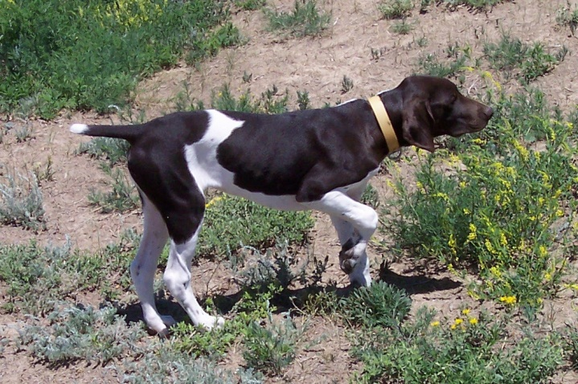
HIGH POINT’S FIRE-SPICED SHIRAZ
Sex: Female
AKC Reg. No.: SR49571106
Whelped: 3/28/2008
Breeder: Susan Herrel
Owner: Susan Herrel
Color/Markings: White and Liver, Patched

Parents____________Grandparents__________3rd Generation___________4th Generation__________ _5th Generation___ FC Sanjo Sin City Slicker Blue Bayou
NFC Heide’s Mighty SE037262 Kiss Me Kate
City Slicker SM845855
Slick’s Country Clown FC Heide Ho-Pinehurst Julson Jessie
SN8151704 SE775695 Erbe’s White Streaker

NFC FC Rawhides Clown FC Jiggs White Smoke
Oakridge Birdie SF2908585 FC Rawhides Jossie Wells
SN331414
3X NSTRA CH Black Forest Brodie Oakridge Josie FC Rosehills Bilbo Baggins
SN91818508 SN008463 Uodibars Gandy Dancer

Prince’s I Saul The Light DC FC Stradivarus Baroque
Sir Moe Bo SN120986 Goodman’s Cadee Delight
SN294204
Prince’s Amazing Grace Armstrong’s Von DL
NSTRA CH Black Forest Sage SN025029 Armstrong’s Do It To It
SN759617
Schmidt’s Ace Payne’s Smoking Ranger
Ford Hill Sadie SF128377 Schmidt’s Miss Twister
SN389060
Ford Hill Classy Sassy Captain Hook’s Pete
SN093370 My Sidekick Alex

Pheasant Buster Bud Bataa Calvin
Jack B. Nimble SN237480 White River Ashcroft Lucy
SN671537
CH Woodrow Kingston Miss High Caliber Gandalf The Grey II
SN80865010 SN478146 Fraulein Hausenpheffer

Sir Moe Bo Prince’s I Saul The Light
Jada B Quick SN294204 Prince’s Amazing Grace
SN574047
RNG’s High Plains Merlot Laybourn’s Meg Buckshot Cheyne
SR07028905 SN423957 Mosegaards Dandy Sasha

Ward Von Burger JH Ward Von Hunter
Gauge VIII SN260183 Mayes’s Jill Babe
SN48475904
Zoe Blazing Star Bradshaw’s Dixie Blazer
RNG’s High Plains Anthem SN29413607 Bradshaw’s Autumn’s Star
SN81595309
Milky Way Kuhlman Sly’s Roscoe v Bowregard
Ingrid Bergman Aleksa SN39230103 Kettlewell’s Sadie
SN59910803
Sadie Renee Kuhlman Sir Maxamallion IV
SN30547804 Frauline Josifein

