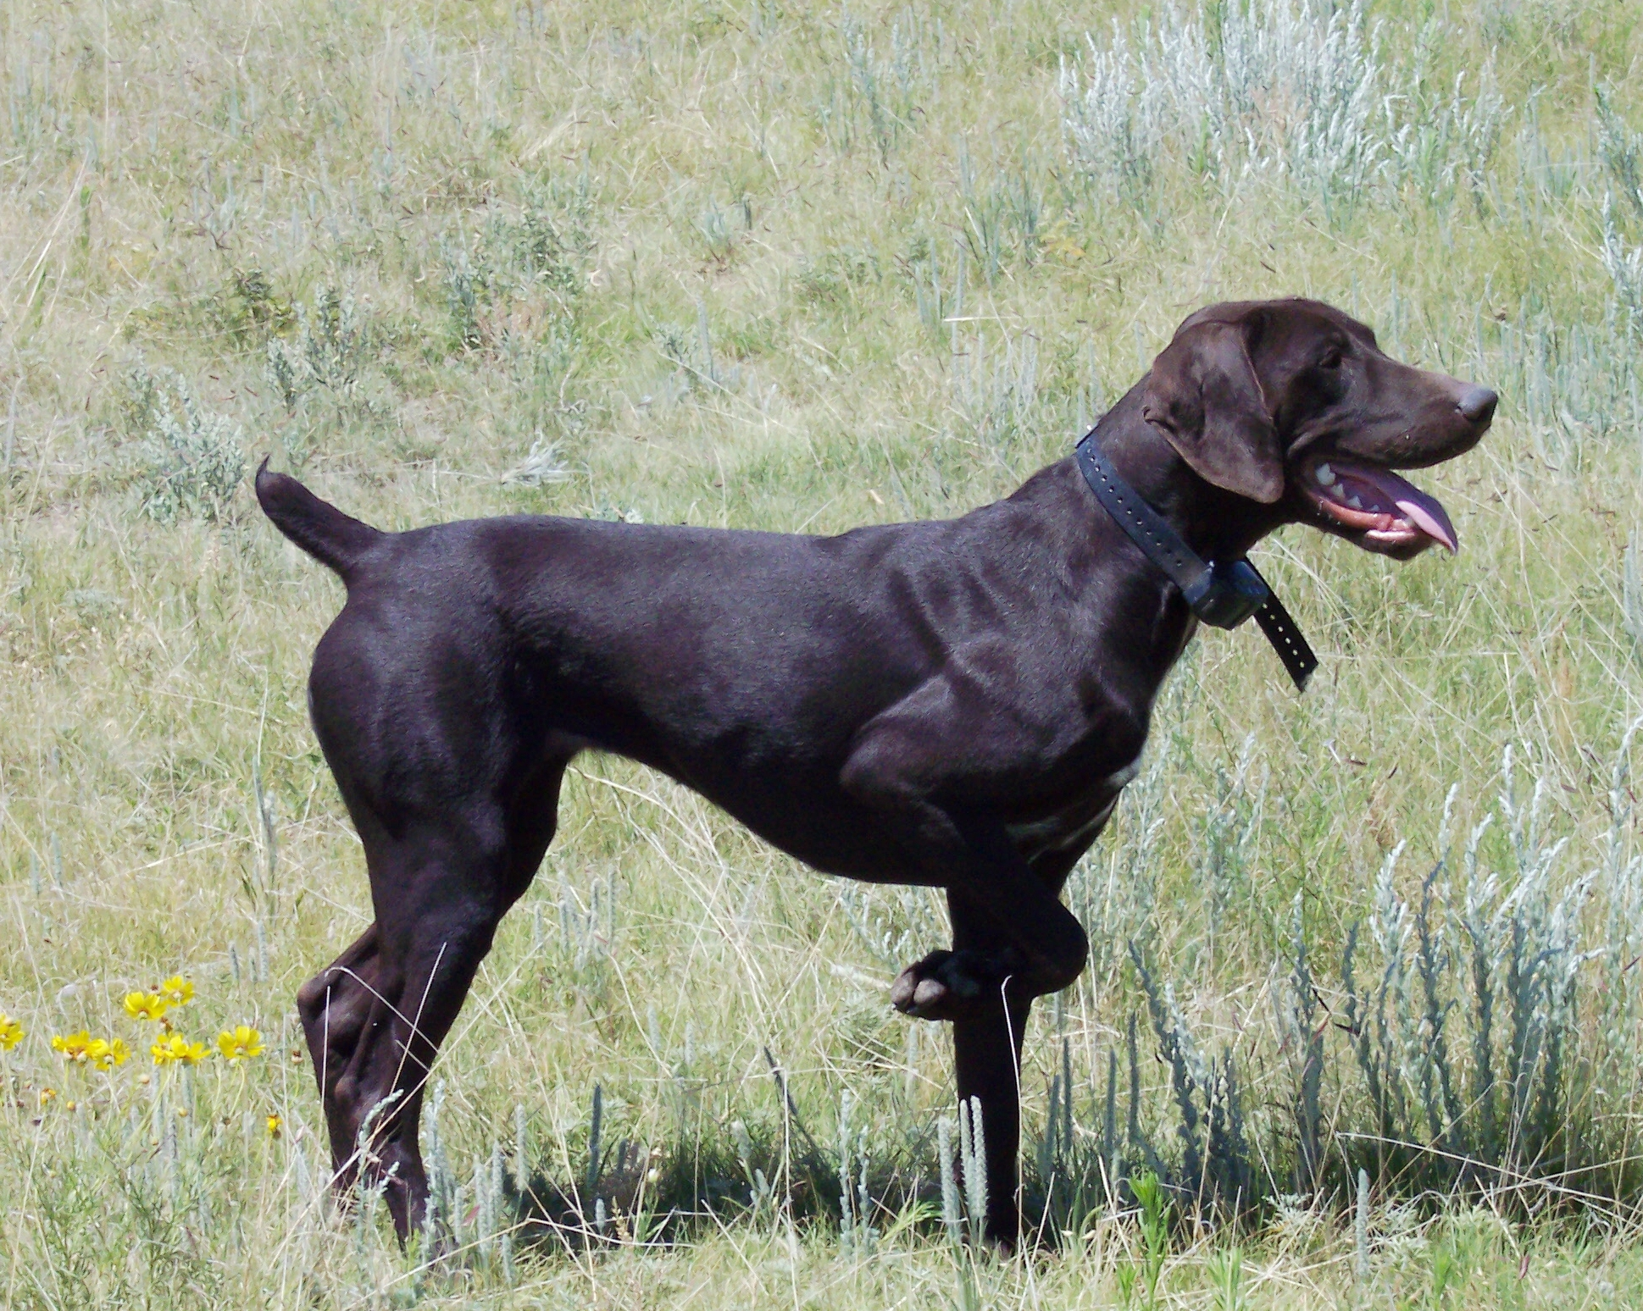
High Point’s Spring-Loaded Action

Sex: Female AKC Reg. No.: SR35637410
Whelped: 06/23/2006
Breeder: Susan Herrel
Owner: Susan Herrel
Color/Markings: Liver

Parents Grandparents 3rd Generation 4th Generation 5th Generation
FC Sanjo Sin City Blue Bayou
NFC Heide’s Mighty City Slicker SE037262 Kiss Me Kate
Slicker SM845503
FC Heide Ho-Pinehurst Julson Jesse
Slick’s Country Clown SE775695 Erbe’s White Streaker
SN81510704
NFC FC Rawhides Clown FC Jigs White Smoke
Oakridge Birdie SF290858 FC Rawhide’s Jossie Wells
SN331414/06
Oakridge Josie FC Rosehills Bilbo Baggins
SN008463/02 Uodibars Gandy Dancer
NSTRA CH Black Forest Brodie
SN91818508 Prince’s I Saul The Light DC AFC Stradivarius Baroque
Sir Moe Bo SN120986 Goodman’s Cadee Delight
SN294204/03
Prince’s Amazing Grace Armstrong’s Von D L
NSTRA CH Black Forest Sage SN025029/06 Armstrong’s Do It To It
SN75961708
Schmidt’s Ace Payne’s Smokin Ranger
Ford Hill Sadie SF128377 Schmidt’s Miss Twister
SN389060/02
Ford Hill Classy Sassy Captain Hook’s Pete
SN093370/08 My Sidekick Alex

FC AFC Beier’s Evolution Beier’s Ace
DC Ziel V Feinschmecker SD933543 Neika Meister Jagerin
SF713219
FC Brookvue’s Gerda FC Chicoree’s Hickory
Arthur V Feinschmecker Garbo SH SE718337 Brookvues Double Fudge
SN1835803
FC AFC Chiroree’s FC Pipeline’s Coco Cola Cowboy
Chicoree’s Almond Joy Cherokee Jake SF048564 FCAFC Essers Wendy VD Wildburg
SF319844
FC Essers Wendy VD DC Esser’s Duke V D
Wildburg SD453491 Dukes Von Patty
Moses’ Maggie Mae
SN80553605 FC Sundance Cisco Kid FC Dixieland’s Rusty
Bluey SE243360 FC Gretchen’s Pride
SF057135
FC AFC Dee’s Call Girl Blueridge Prince Charles
NSTRA CH Moses’ Blue Streak SC690624 Blue Ridge Mountain Patsy
SN161397/05
Keefer Der Meister Veno V Campbellhaus
Cochrane Whitney Keefer Fallschirmjager SF195845 Starlit Heidi Campbellhaus
SM879177
In Due Time Dusty FC Checkmate’s Dandy
SF451827 Egyptian Doctors Miss Kirby

