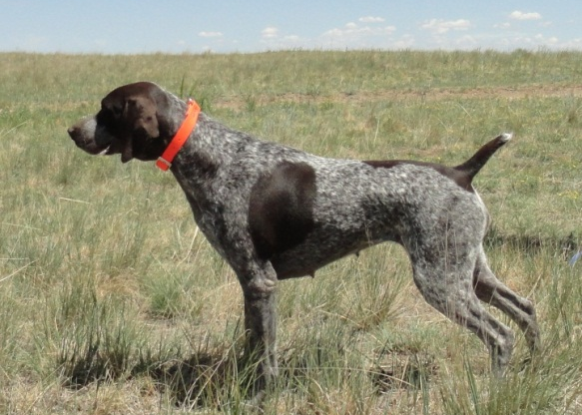
HIGH POINT’S TREASURED TRINKET
SEX: FEMALE
AKC REGISTRATION #: SR60461209
WHELPED: 12/27/2009
BREEDER: SUSAN HERREL
OWNER: SUSAN HERREL
COLOR: LIVER AND WHITE, PATCHED AND TICKED

PARENTS GRANDPARENTS 3RD GENERATION 4TH GENERATION 5TH GENERATION
Stradivarius Excalibur CH Stradivarius Maximilien
Rockpoint’s Dash’N Nash SN272062/01 Holle V Der Stolzen AU CKC
SN336616/10
Bradley’s Abigail DC AFC Stradivarius Baroque
CH High Point’s Flintlock Baroque SM877050/11 Hustlebergs Beauann’s Cayla
SR19547001
Frederick Otto V Dukus Otto Je Schokolade Hund
Heidi Von Dukus SN655525/03 Phantasie Blume Flicken
SN33661610
Our Lovely Lucille White River Shultz
SN717142/02 Dewitt Darling Daisy Mae
High Point’s Rough House N Rowdy
SR48035507 Slick’s Country Clown NFC Heide’s Mighty City Slicker
NSTRA CH Black Forest Bodie SN81510704 Oakridge Birdie
SN91818508
NSTRA CH Black Forest Sage Sir Moe Bo
NSTRA CH High Point’s You SN75961708 Ford Hill Sadie
Dazzle Me SR19462604
Arthur V Feinschmecker DC Ziel Feinschmecker
Moses’ Maggie Mae SN1835803 Chicoree’s Almond Joy
SN80553605
NSTRA CH Moses’ Blue Streak Bluey
SN161397/05 Cochrane Whitney Keefer

Pheasant Buster Bud Bataa Calvin
Tanner Buscal Royale SN237480 White River Ashcroft Lucy
SN720930
Rawhide Clowns Chocolate Miss High Caliber Gandalf The Grey II
Chip SR277028/07 SN478146 Fraulein Hausenpheffer

FC AFC Gabbe’s High Plains FC AFC Downs Chocolate Moose
Maggie Wildfire Hurricane SF900309 NAFC FC AFC Ranger’s Essergreif’s Gabbe
SN874713
Smokey J R Rose NFC FC Rawhides Clown
SN391208/04 Penny J R Rose
High Point’s Lark’s Gimmick
SR44864709 Jack B. Nimble Pheasant Buster
CH Woodrow Kingston SN671537/03 Miss High Caliber
SN80865010
Jada B Quick Sir Moe Bo
SN574047/09 Laybourn’s Meg
RNG’s Lucien’s Liaison
SR07028902 Gauge VIII Ward Von Burger JH
RNG’s High Plains Anthem SN48475904 Zoe Blazing Star
SN81595309
Ingrid Bergman Aleksa Milky Way Kuhlman
SN59910803 Sadie Renee Kuhlman

